**DA ASSIGNMENT-2**

**Name:** N.Rajitha

**Roll No:** 22BFA05307

**Course:** Data Analytics with Tableau

1.Donut Chart

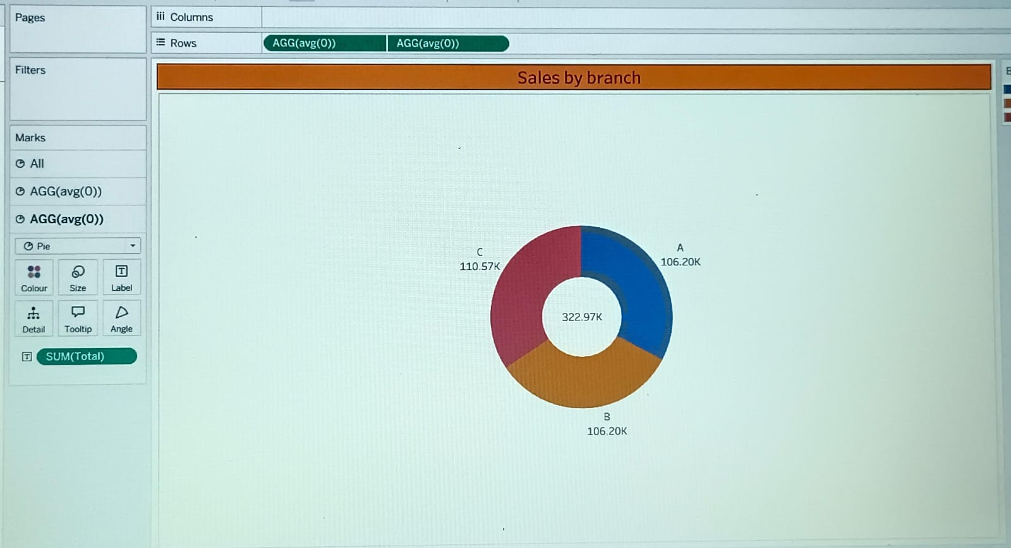

2. Area Chart

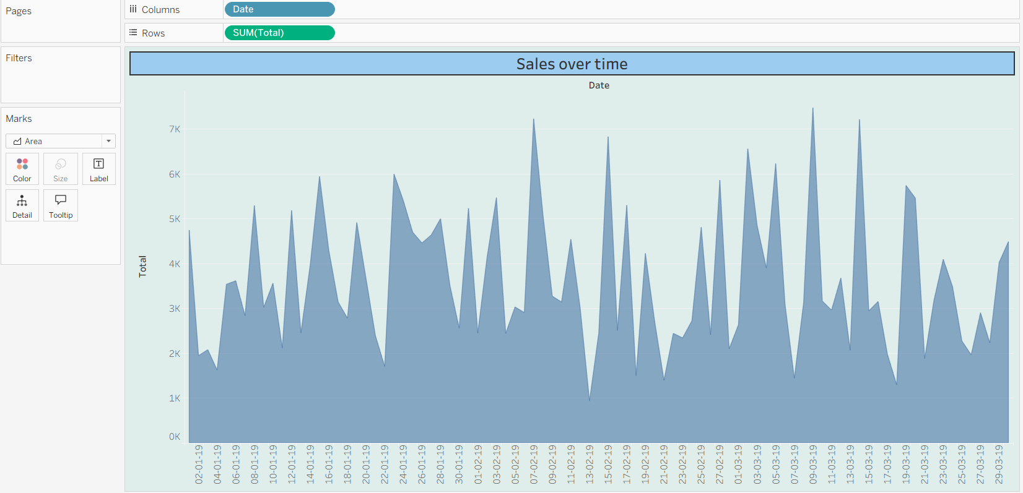

3. Text Table

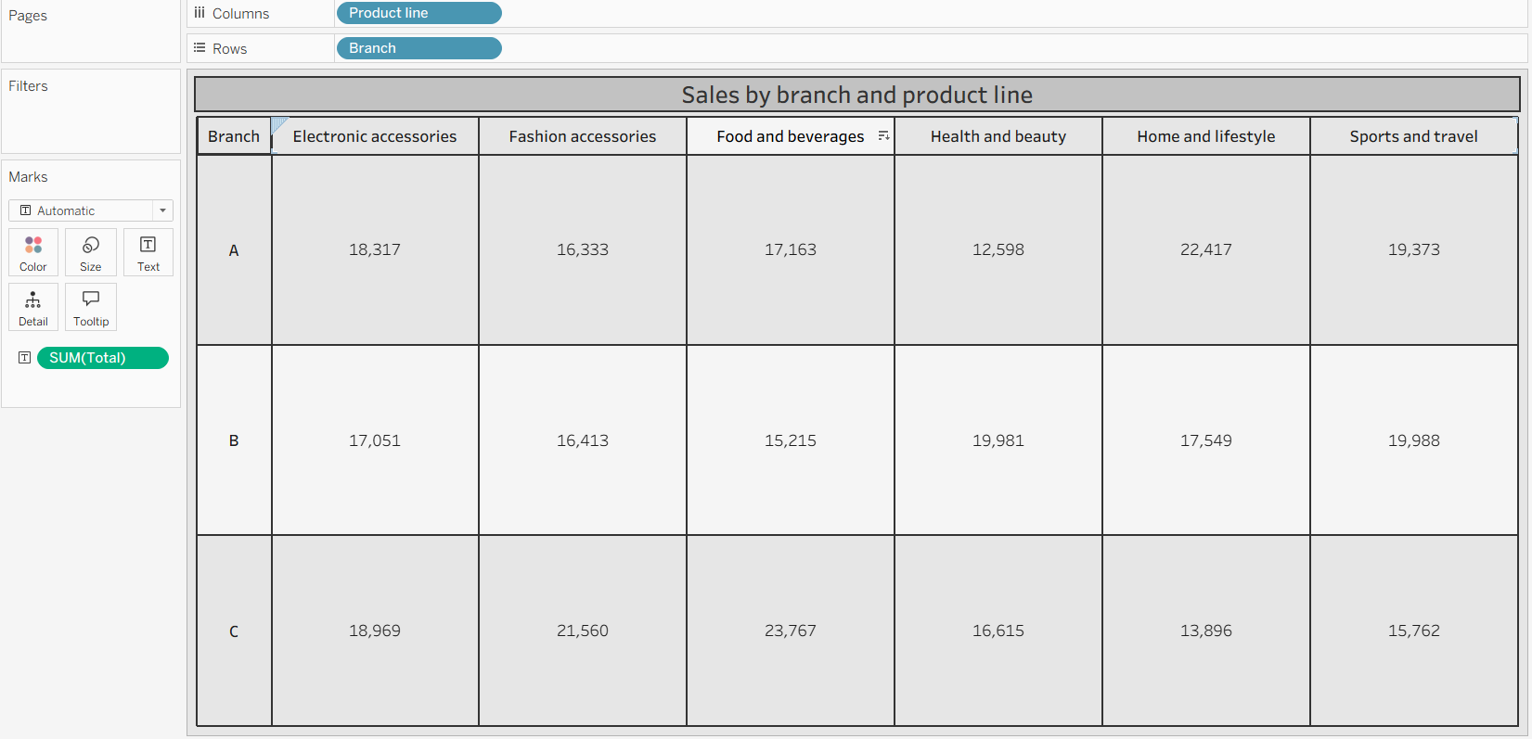

4. Highlight Table

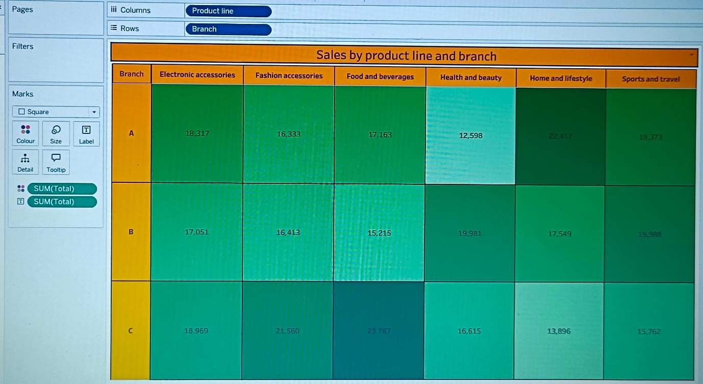

5. Word Cloud

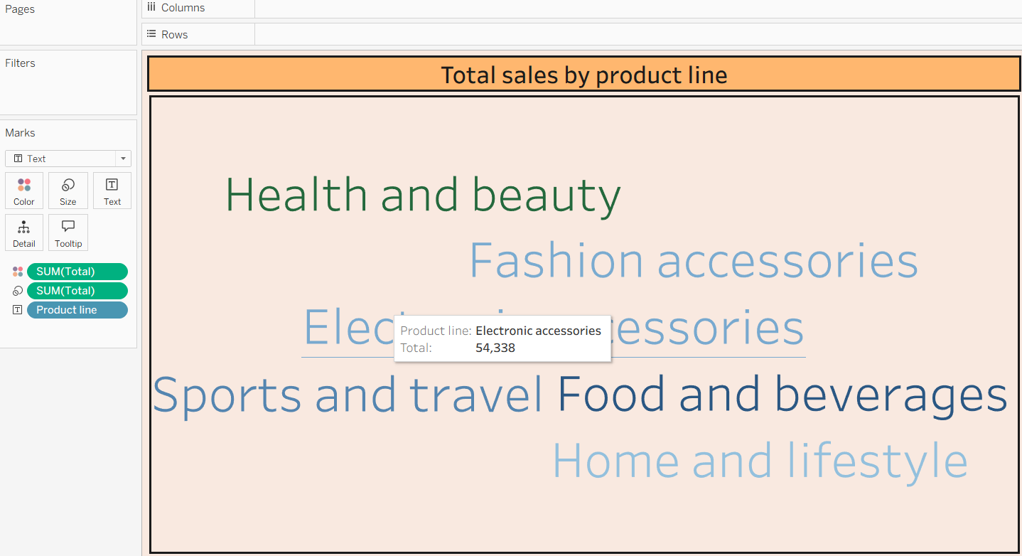

6. Funnel Chart

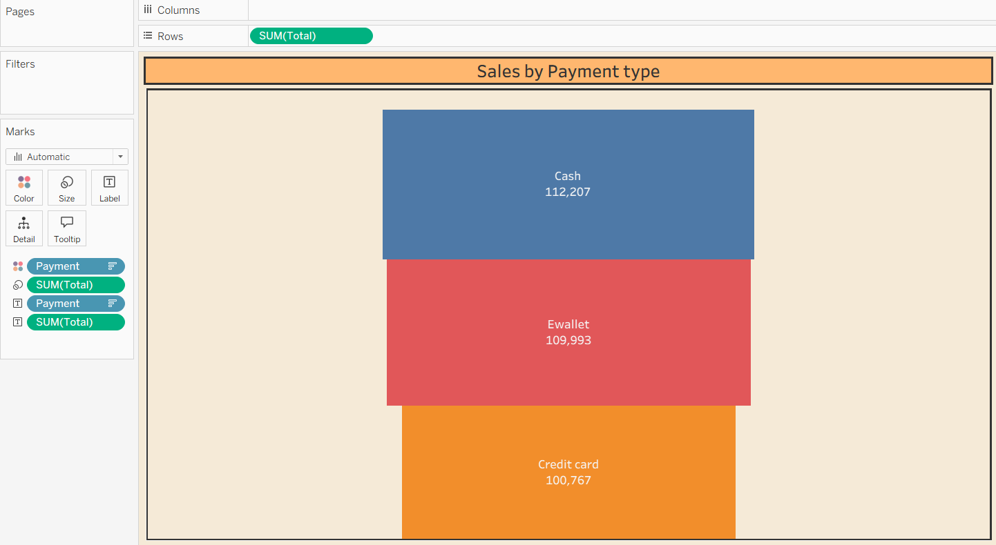

7. Waterfall Chart

